SCREESHOTS FILE
Course-end Project 2
Deploying Multi-Tier Application
Solution:
Step 1: Create an EC2 instance and launch it.
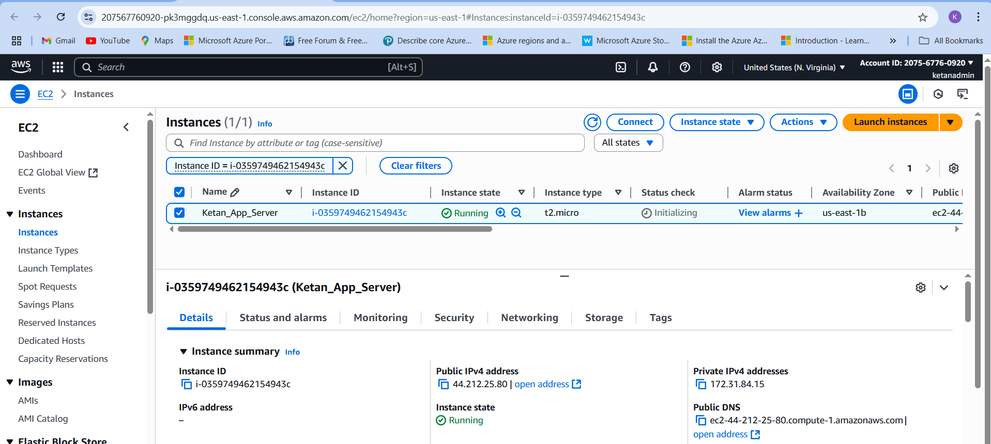

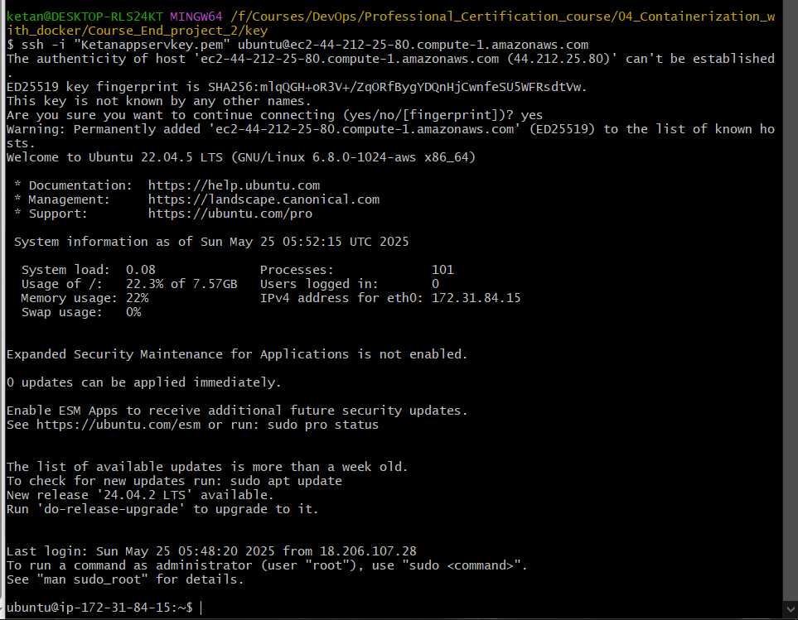

Step 2: Set up the environment by installing the required software (Docker, Docker Compose, Git)
Docker:
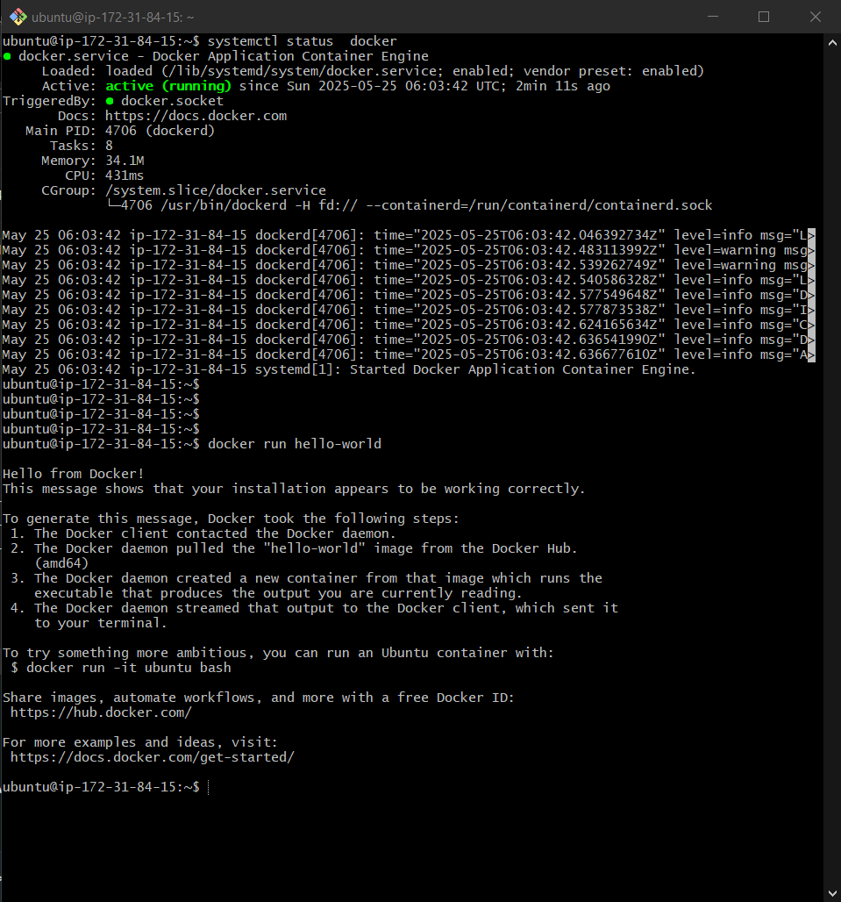

Docker Compose:
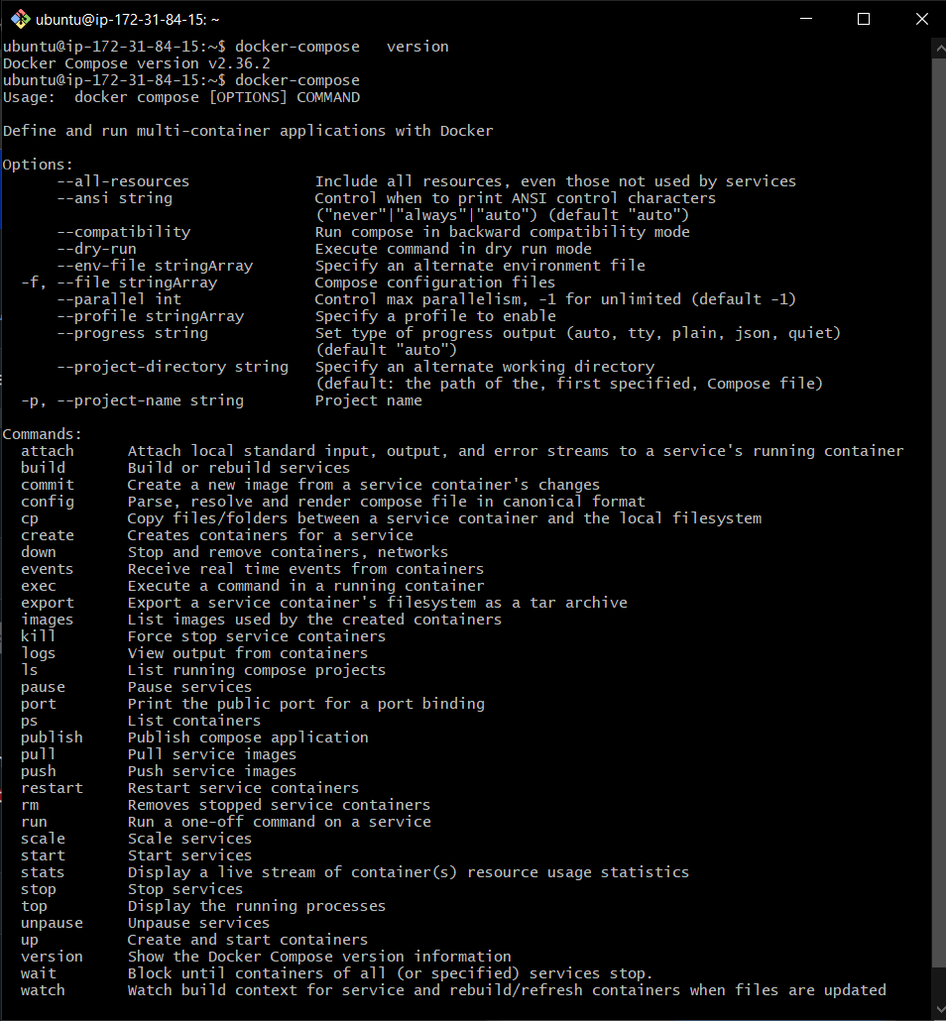
GIT:
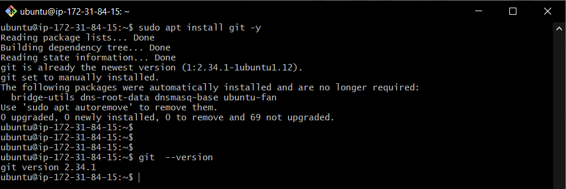

Step 3: Clone the application repository and update configuration files with the machine's public IP and deploy the multi-tier application.
Cloning the application
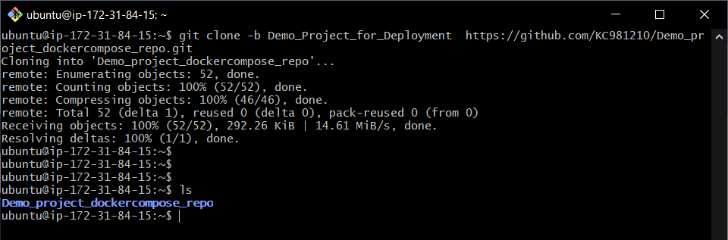
Frontend.env file updated with public IP address.
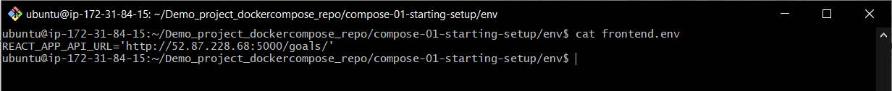
Configuring inbound traffic on port 8080 and 5000
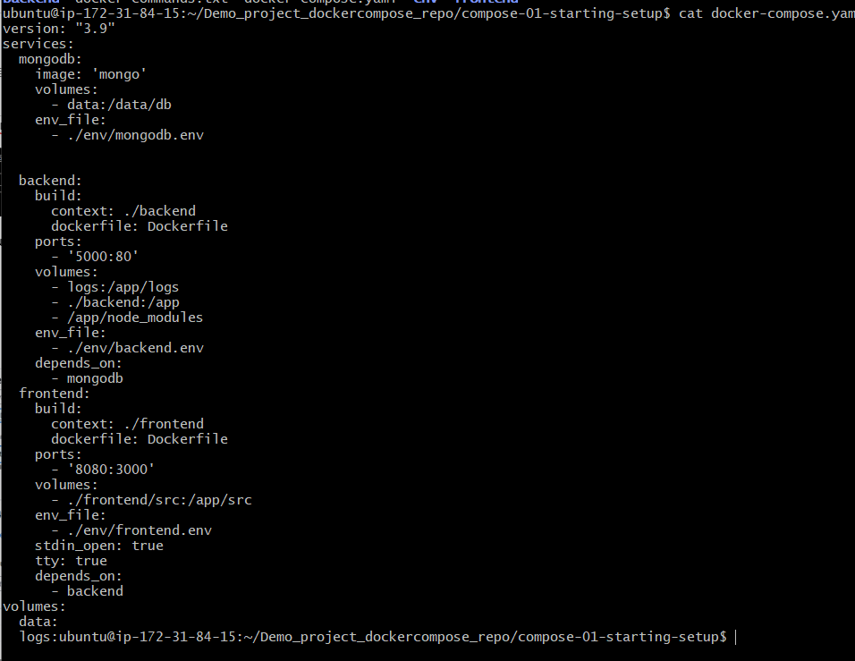
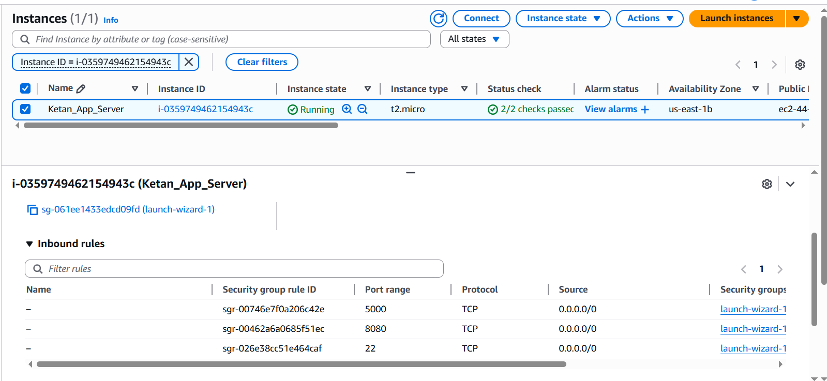

Deploying Application using docker-compose up -d command
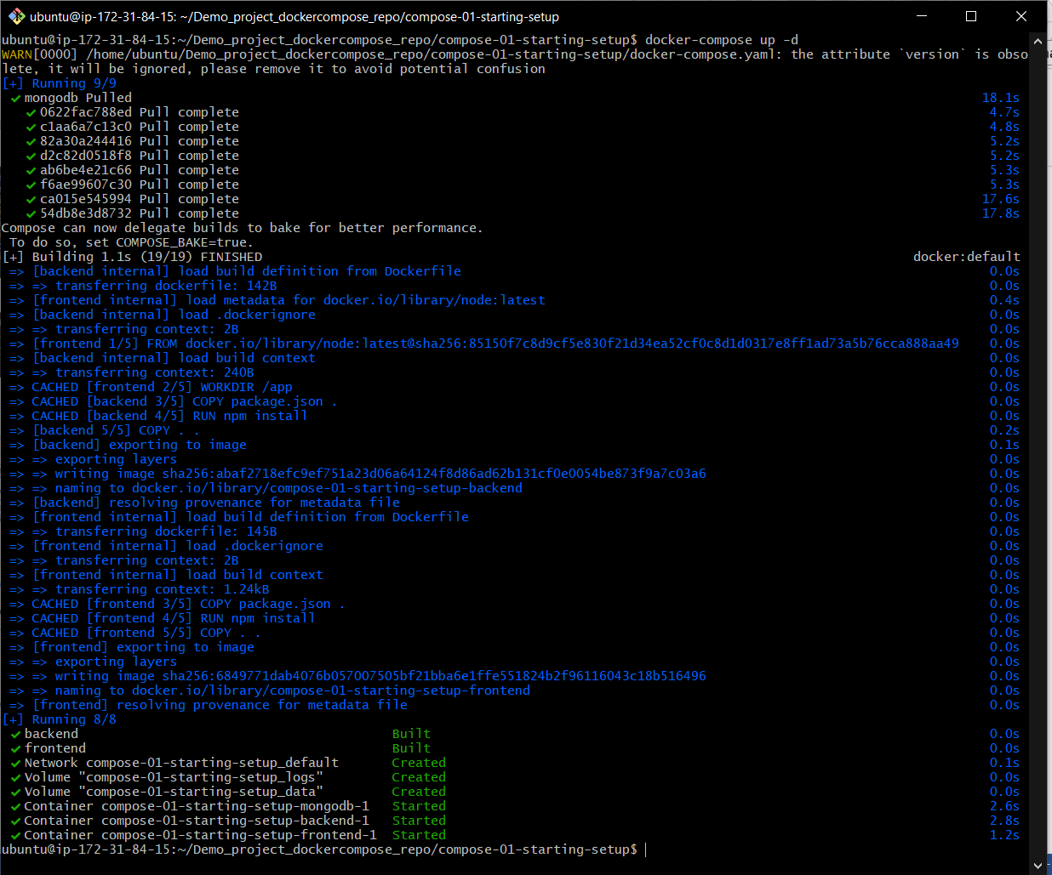

Step 4: Access and verify the application
Frontend:
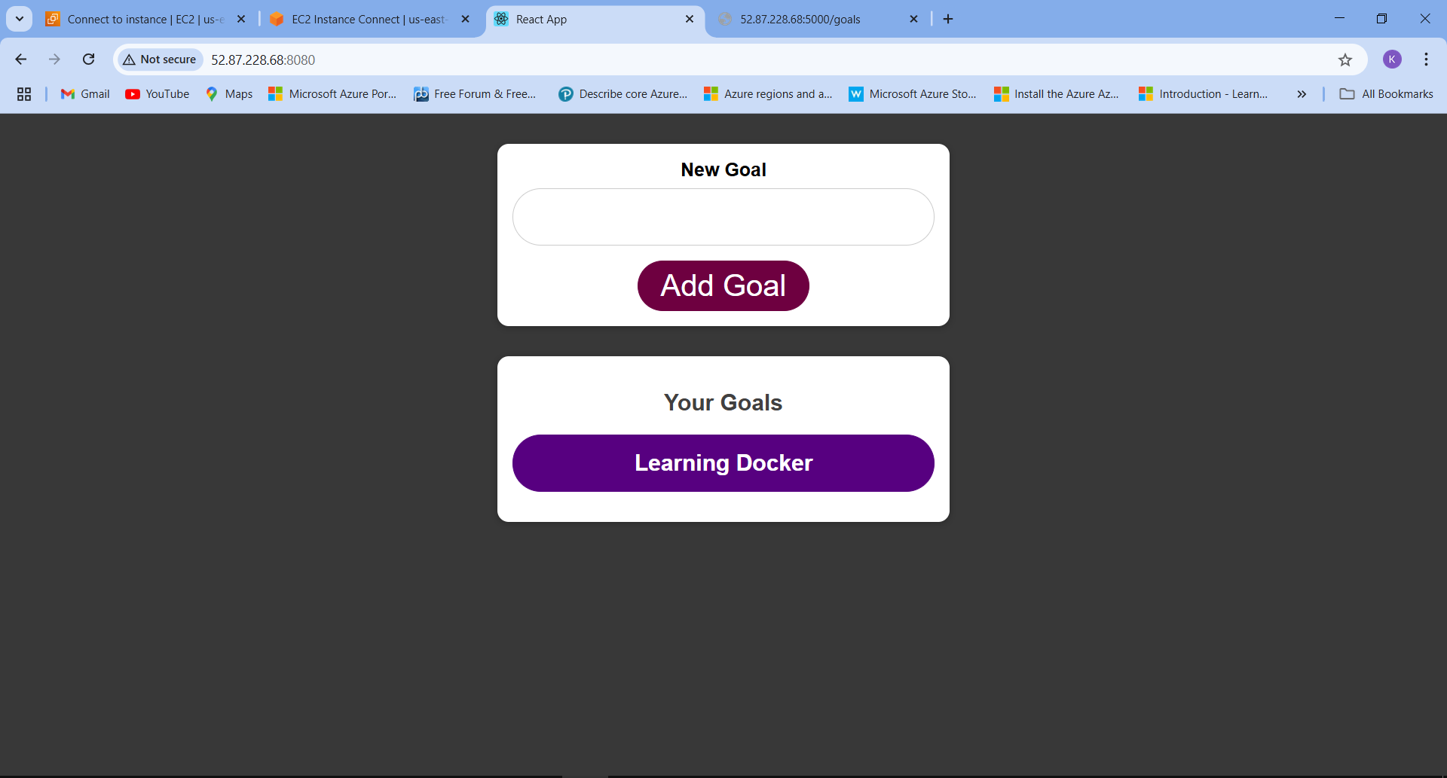

Backend:
